Common name: cranberry fruitworm

Scientific name: *Acrobasis viccinii* (Riley) (Insecta: Lepidoptera: Pyralidae)

Introduction

Crandberrry fruitworm (*Acobabsis* *vaccinii*) (**Figure 1**) is an important crop pest of American cranberry, (*Vaccinium macrocarpon*) Aiton, is the cranberry fruitworm, Acrobasis vaccinii Riley (Lepidoptera: Pyralidae) (Mahr 2005, Fitzpatrick 2008). This moth also attacks other Vaccinium crops, such as the highbush blueberry, Vaccinium corymbosom L. It is a native, univoltine pest that emerges mid-summer, feeds on fruit, then overwinters as a prepupa within hibernaculae in the soil (Mahr 2005, Fitzpatrick 2008). Adult A. vaccinii emerge in late spring. Their phenology is closely linked with the cranberry plant because once the adults emerge, females begin ovipositing a single egg on the calyx of the unripened berry (Mahr 2005, Fitzpatrick 2008, Medina et al. 2014). Importantly, the five larval instars (Godin et al. 2002) develop within the berries, feeding solely on the fruit, each individual destroying up to 11 berries throughout its development (Mahr 2005, Fitzpatrick 2008). Reports have documented A. vaccinii destroying up to 50% of a cranberry crop at a given marsh (Mahr 2005).

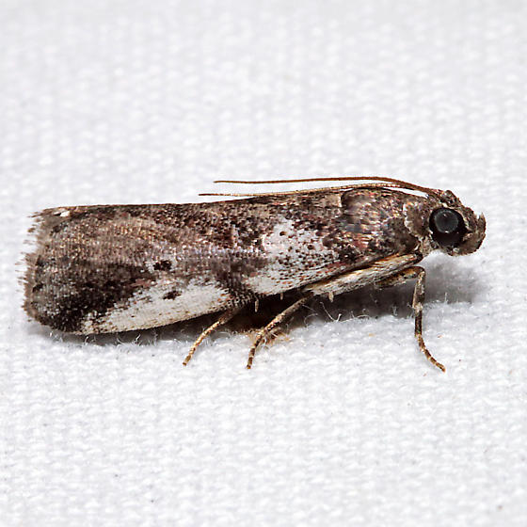

Distribution

Quebec, prince Edward island, nova scotia, maine, Massachusetts, Rhode Island, Connecticut, New York, New Jersery, North Carolina, Michigan, Wisconsin, Texas, and Washington.

Description

Economic Importance

Host range limited to two plant genera, *Vaccinium* and Gaylussacia. Larvae feed on the marketable fruit of highbush blueberry, deerberry, and cranberry.

Cultural Importance

Selected References

Averill, A. L., M. M. Sylvia. 1998. Cranberry insects of the northeast. 46-51